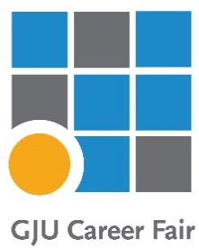
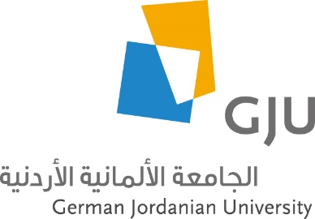

DI-TECH - Deanship of Innovation, Technology Transfer and Entrepreneurship

13th GJU Career Fair 2024
Event Report

The 13th annual GJU Career Fair 2024 was held by The Deanship of Innovation, Technology Transfer and Entrepreneurship on 29th October 2024.
The event was a great opportunity to connect companies with our graduates and students.
Venue:
The event was held at the Sports Hall, which was the perfect space to hold this event, as it was an added value to the structure and arrangement of the career fair.

Registration & Participation:
The registration process for the career fair was through a tailor-made web site developed and maintained by Eng. Hadi Etawi.(Information System and Technology Center)

Dr. Hamza Al-Majali was the head of the organizing committee with member from different university departments involved in planning the career fair and serving the event.

From the committee members, the effort to follow up on company registrations, assist them, and complete all procedures was managed by Eng. Sondos Almashaileh, Ph. Hadeel Almaayah, and Eng. Alaa Alshubbak. The logistics was the responsibility of Eng.hala aleyadah.

Total number of participating companies: 65 company representing variable industrial sectors in Jordan, Germany & MENA region. A list of companies is included in this report. (Table 1)
This year ,It was very noticeable that many of the company representatives who participated in the career fair were GJU graduates.

Total number of visitors: approx. 1000 visitors (students, graduates and faculty members)

Payment & Financial:
The event was sponsored according to the following details:

Company Name | Sponsorship Kit | Amount
Orange Jordan Company | Gold | 3000 JD
Alfanar | Silver | 2000 JD
German Energy Academy in Jordan (صندوق عبد العزيز الغرير ) | Silver | 2000 JD

Since this event is self-sustained in expenses, the participation fees for companies were 200 JOD for the booth, with special rate of 150 JOD for the Dual Studies partner companies. Total was 14950 JOD, including the sponsorship amount.

Total expenses of the event were 7704.8 JD.

Company Assistants & Students Employees:
Students from the Innovation Club actively assisted in organizing the event and played a vital role during the event day.
Approximately 80 students were selected as ushers, with each assigned as a Company Assistant to one of the participating companies. It is worth mentioning that most companies provided positive and enthusiastic feedback about their company assistants.

Career Fair Handbook
As in previous years, we have published a career fair handbook. addition, this year, an electronic version of the handbook was posted on the career fair website that all visitors to the exhibition can access to obtain information about the participating companies and guide them during the event. The goal is provided information about the participating companies, their profiles, the specializations they are interested in and what they had to present at the career fair

Credits for preparing the Career Fair Handbook goes to Ms. Shatha Alfraij. (Public Relation Department)

Career Fair & Dual Studies:
15 of our Dual Studies partners participated in the career fair this year. The fair was a good opportunity for the Dual Studies company acquisition team to meet potential partners and introduce the program to them.

The analysis of career fair
Visitor’s survey

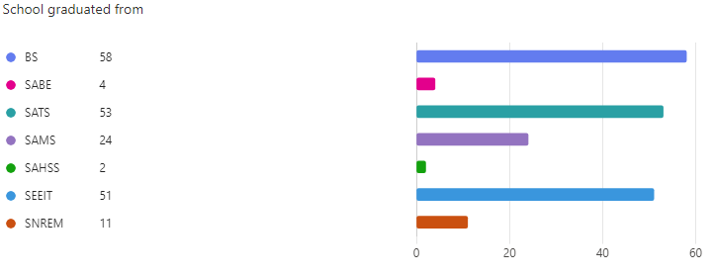

Figure 1:
The chart shows that BS, SATS, and SEEIT have the highest number of graduates attending the career fair , while SABE and SAHSS have the lowest. This suggests strong engagement or larger programs in BS, SATS, and SEEIT. To increase participation, targeted outreach to schools with lower numbers could be beneficial.

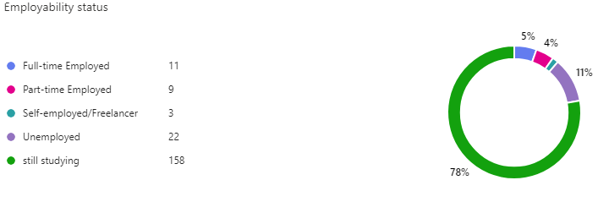

Figure 2:
The chart indicates that 78% of participants are still studying, while 11% are unemployed. A small portion is employed full-time (5%), part-time (4%), or self-employed (2%). The majority being students suggests this event is mainly attracting current students rather than recent graduates or job seekers.

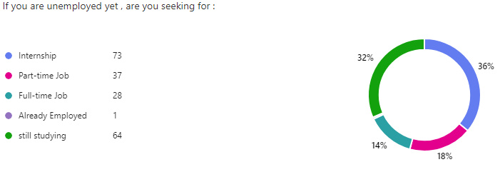
Figure 3:
The chart shows that 36% of respondents are seeking internships, while 32% are still studying and not actively looking for jobs. Among those seeking employment, 18% are interested in part-time jobs, and 14% in full-time roles. This suggests a high demand for internships, likely from students aiming to gain experience.
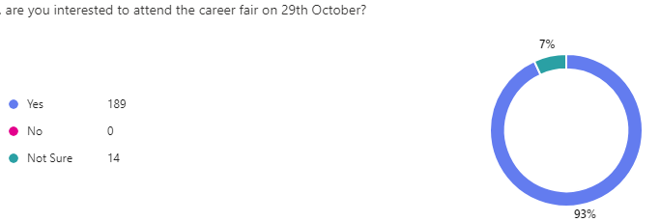

Figure 4:
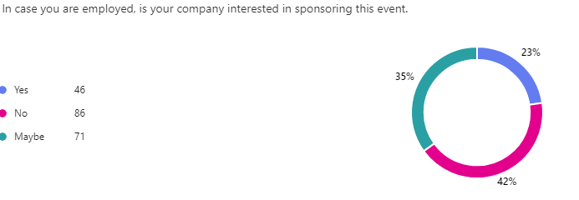
This chart shows the level of interest in attending a career fair on October 29th. An overwhelming majority (93%) responded “Yes," while 7% are "Not Sure," and no respondents answered "No. This indicates strong interest in participating in the event, with only a small percentage undecided.
Figure 5:
This chart shows survey results regarding company interest in sponsoring an event.
The majority (42%) responded "No," while 35% responded "Maybe," and 23% responded "Yes." This indicates that interest in sponsorship is generally low, with uncertainty being the second most common response.

