Num. | Club name | Short Describe
1. | Community Service Club  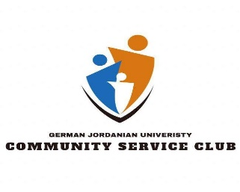 | To develop volunteerism amongst GJU students in a nurturing environment that fosters community service.
2. | Environmental & Health Club | Promote environmental education and focus on some important environmental issues in the community.
3. | Robotics Club  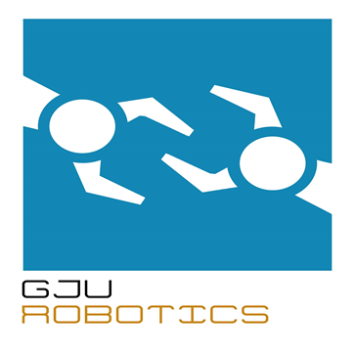 | The job training courses on robotics and engineering fields and help the students in their projects and research.
4. | Information technology club  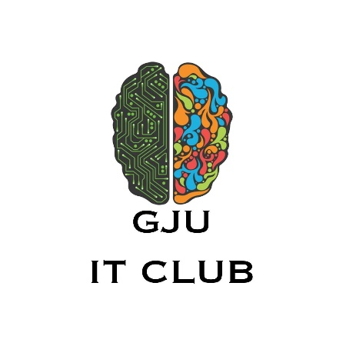 | support the practical side of information technology through activities related to raising the efficiency of the technical students
5. | German Association Club – GAC | Integrate both local and foreign students in a healthy atmosphere and create an understanding between both cultures, in addition to exchange views, opinions and thoughts would could lead to enriching both parties, as well as getting rid of common misconceptions, and stereotypes.
7. | Book-Busters club | "Book Busters" aims at encouraging the younger generation to read more by presenting what they have read through acting with the help of the team members
8. | Model United Nations (MUN) | Increase educate students and equip them with skills sound debate and discuss a variety of issues of interest to and affecting the world of work and through the work of workshops and the annual conference, which discussed the following matters economy develops eco-friendly, human trafficking, censorship on the internet.
9. | Theater and Drama club  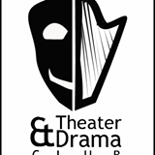 | Showing plays about the student topics and some issue in the community
10. | Business Students Club ( BSt)  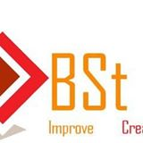 | Execute some activity related with business and mini project.
11. | Industrial Engineers Club  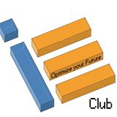 | Training and workshops related with industrial engineering
12. | Arabic club | Interest with Arabic language by celebration of special events in the Arabic language and encourage reading
13. | IEEE | A non-profit organization, IEEE is the world's leading professional association for the advancement of technology.  The IEEE name was originally an acronym for the Institute of Electrical and Electronics Engineers, Inc. Today, the organization's scope of interest has expanded into so many related field

