Germany Survival Guide
GJU Staff Mobility Program

We are happy to share with you the “German Survival Guide” in which we have gathered important information regarding life and culture in Germany. This may help you before and during your stay in Germany.

Content
1. General Information about Germany 2
2. Culture 5
3. Daily live 6
4. Transportation 9
5. Other things to know 12
6. Activities in free time 14
7. Public Holidays 17

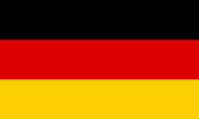
General Information about Germany
 | Jordan | Germany | Germany is/ has…
Size | 89,320 km² | 357,580 km² | 4x bigger
Inhabitants | 10 Mio. | 83 Mio. | 8x more people
Average age | 23,5 | 47,8 | Twice as old
Currency | Dinar (Piaster) | Euro (Cent) | Change: 1 JOD = 1,25 €
Unemployment | 18,5% | 4,3% | 4x less unemployed people
Rain days per month | 1,7 | 9,9 | 5x more rain days
Statistics

Germany is a parliamentary republic in the heart of Europe. The Federal Republic of Germany is also one of the founding members of the European Union. With over 83 million inhabitants, it is the second-most populous country in Europe and the most populous member state of the European Union. Germany’s youth and young people under 30 make up not even 30% of the population (for comparison: Jordan has one of the youngest populations in the world with 63% under 30 years).
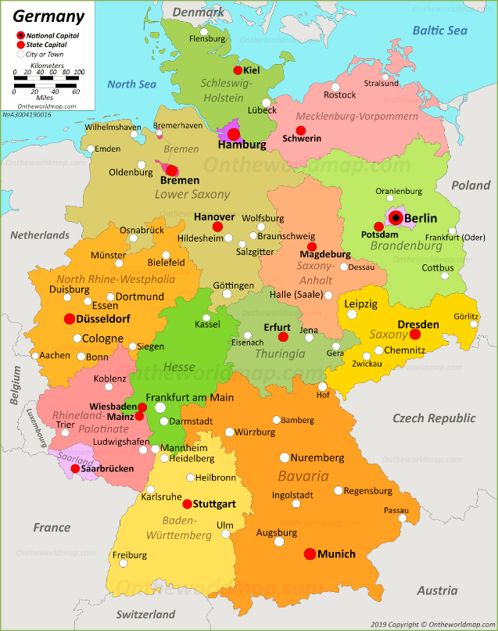
Furthermore, Germany is the largest economy in Europe, the 4th largest economy in the world and the 3rd largest exporting nation in the world. Companies such as Volkswagen, Bayer or Siemens come from Germany.
Since the reunification in 1990, Germany has 16 federal states (“Bundesländer”). On the right side, you can see the 16 federal states and the main cities. The capital of Germany is Berlin.
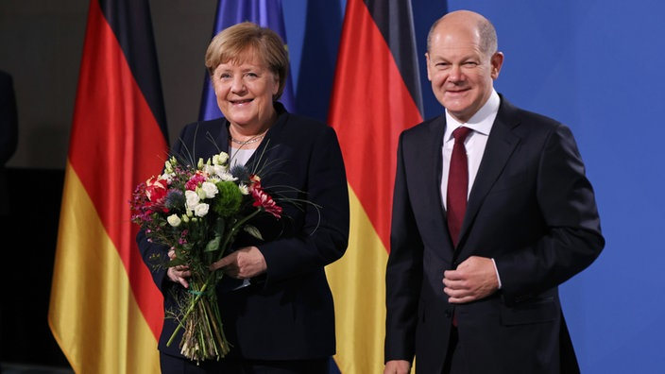
Politically, after 16 years of Ms. Angela Merkel’s (party: CDU) leadership as the chancellor, Mr. Olaf Scholz (party: SPD) has been voted as the new chancellor in December 2021.

Brief History Overview
- 1914 – 1918: World War 1 (Germany is defeated)
- 1919: Treaty of Versailles Germany has to give up territory and pay reparations
- 1919 – 1933: Weimar Republic
- 1933: Hitler becomes chancellor of the German Reich
- 1939 – 1945: World War 2 (Germany is defeated)
- 1949 CE: Split of Germany in East and West
- 1961 – 1989: Berlin Wall
- 1990: Reunion of Germany Berlin is capital
- 2002: Euro replaces the Deutsche Mark

Law
The first paragraph of Germany’s basic law states: Human dignity is inviolable. This is a fundamental law in Germany that goes along with the fact that Germany is a tolerant and free country. The basic law guarantees freedom of thought, conscience, religion, press, and opinion.

Religion
There is no state religion in Germany and the state guarantees religious freedom. Christianity is the largest religion in Germany, the Islam the biggest minority religion. You will find churches in every small town or village, and mosques, synagogues or temples, mostly in bigger cities. Germany and its daily life is Christian influenced. This reflect in several things, for instance, most holidays (Section 7) and traditions like Christmas are based on the Christian belief. Moreover, the Church is the second biggest employer after the State and plays a big role in social and cultural life such as in schools. Nevertheless, over one third of the Germans does not have a confession/religious denomination with increasing tendency. It is important to state that many Germans quit the Church as they do not agree with the patriarchal structure or missing consequences for crimes committed in the name of Church. Therefore, having no confession is not the same as being non-religious.

Religion in Germany

LGBTQI+ and third gender
The fact that Germany is a very liberal, multicultural, and diverse country also includes freedom regarding the LGBTIQ+ (lesbian, gay, bisexual, transgender, intersexual, queer) community. Please be prepared to see public display of affection, as it is considered normal in Germany.

In some parts you might find “Unisex” toilets where all genders are allowed to enter.

Culture
It is hard to grasp a culture completely and it might be different from each area you are in and who you talk to. Nevertheless, we tried to describe some “typical” German cultural aspects:
- Germans love their rules and stick to it
- Germans love punctuality and it’s quite impolite to be late (especially with the older generation). So try to be in time (or like the Germans 5 min earlier).
- When standing in the queue, just wait patiently until it’s your turn. Nobody cuts the line and that is considered very rude.
- Wait for the green light to cross the street – otherwise people might disapprove, shake their heads and give you a lecture about not being a good example for kids.
- When entering a home, take off your shoes.
- When in the cinema, concert or theater, try to eat silently, turn off your phone and just whisper if you need to talk at all
- When meeting with someone, switch off your mobile phone (no vibration either), don’t let it stay on the table and only use it in an emergency – being on the phone is considered impolite.
- If you eat together on one table, wait until everybody sits until you start eating
- The Germans do not kiss for welcoming, but shake hands. Shake the hand of the women first, after that in hierarchy. Close friends hug, even between genders. Now, in Covid-19 times, the fist bump might be an option 😊
- Germans have a very direct manner when communicating. Don’t take it personal and also feel free to speak your mind respectfully.
- Respect the night rest from 10 PM until 6 AM and Sunday as the private day of the week.
- Smoking is forbidden inside closed public rooms like cafes, restaurants, playgrounds or public transports. Also, throwing cigarettes on the floor can be expensive (up to 90€ depending on the city) and harms the environment. On train platforms, look for designated smokers areas.
- Germans expect a high level self-independency, so please always stay up-to-date, inform yourself on websites and show initiative. If then any questions come up, Germans are happy to help you.

Daily live
In contrast to Jordan, the weekend in Germany is on Saturday and Sunday. On Saturday, service such as the post office might close earlier, keep that in mind. On Sunday, supermarkets and other official stores are closed. The bakeries are open in the morning (but not all of them) and in case you forgot to buy food in the supermarket, there is a chance that there is a store at the main railway station or petrol station where you can buy basic stuff. Restaurants are often open on Sunday, but check online first.
Food
Restaurants are more expensive in Germany than in Jordan. You usually give around 10% as a tip, which is not included in the bill. You will find lots of different restaurants from all over the world in each city (there are a lot of good Arabic restaurants). Furthermore, the cutlery in Germany sends messages:
    - Crossing (left): “I am still eating”
    - Crossing (middle): “I am waiting for the next course”
    - Side by side (right): “I have finished”

A cheaper alternative is to look for an “Imbiss” or streetfood.

When it comes to meat, please be aware of pork meat which is used a lot in German cuisine. Also, food is mostly not halal. Feel free to ask before you buy something. But you will also find Turkish or Arabic supermarkets that sell halal food.
Supermarket
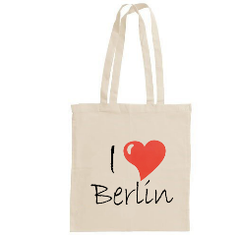
Food and beverages are cheaper in supermarkets. Since you can drink the tap water in Germany, no need of buying water. If you buy bottles and cans, keep in mind the below mentioned Pfand system. Alcohol is served in most places and sold in every supermarket. More expensive supermarkets are REWE and Edeka, cheaper the discounter such as ALDI, LIDL, Kaufland, Netto and Penny.
In Germany, you don’t get plastic bags for your purchase. You can either buy paper bags in the supermarket, but it is recommended to buy two or three textile bags that you take with you to the supermarket (reusable bags).
Typical food
In Germany, there is no typical dish such as Mansaf in Jordan. The food also depends a bit on the region you are staying in (e. g. fish in Hamburg, Maultaschen in the south etc.). Here you see a small overview of some typical German dishes:

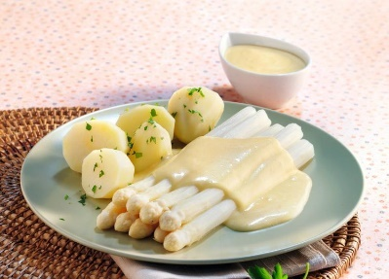
“Spargel mit Sauce Hollondaise”
Seasonal vegetable served with creamy sauce.

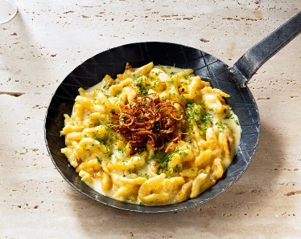

“Käsespätzle”
A type of paste with cheese sauce

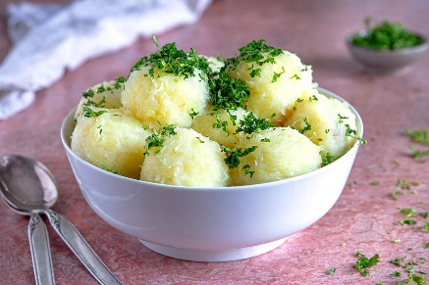

“Klöße/ Knödel”

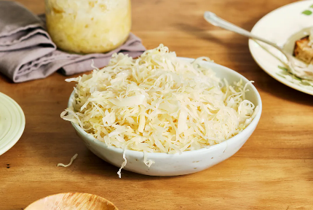

“Sauerkraut“
Type of cabbage

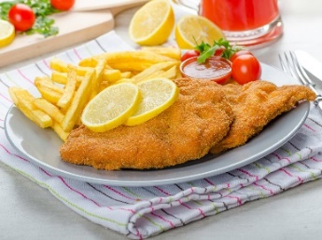
“Schnitzel mit Pommes”
- Wiener Schnitzel – made from veal (cow)
- Schnitzel Wiener Art – made from pork ❌
- Sometimes it’s made from chicken

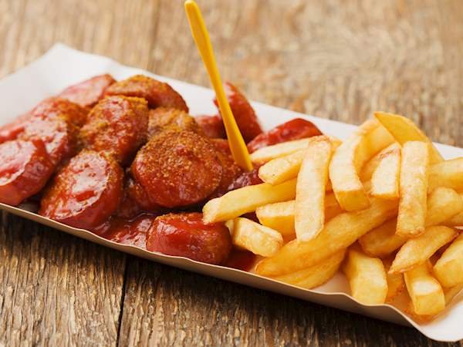
“Currywurst”
Often made of pork – ask if they also have “Wurst” made of cow.

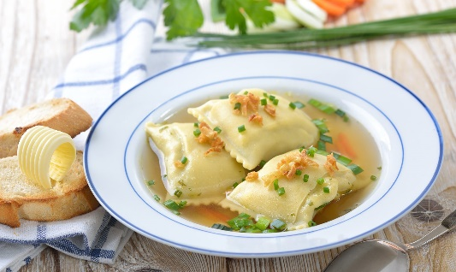

“Schwäbische Maultaschen”

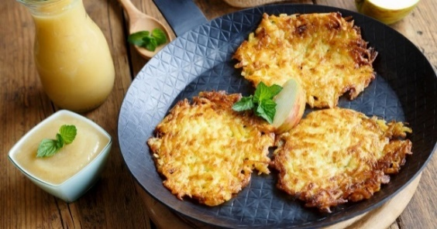
“Kartoffelpuffer”
Made of potatoes and eggs.

Bakeries
In German bakeries, you can find a variety of bread (wheat bread, spelt bread, rye bread, potato bread, walnut bread– there are up to 3000 different sorts of bread), buns (“Brötchen”; small breads with different grains) and sweets (see the below selection). You will find a lot of bakeries in every city. Also try the different cakes (apple cake, cheese cake …)!
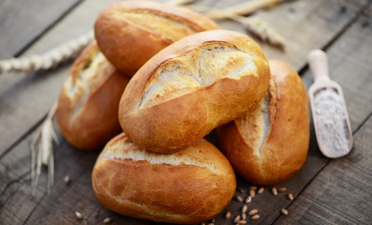
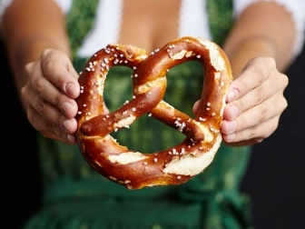
The „German Bretzel“ „Brötchen“ (a common breakfast)

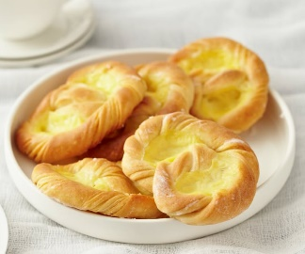
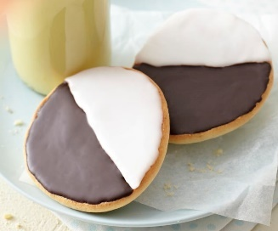
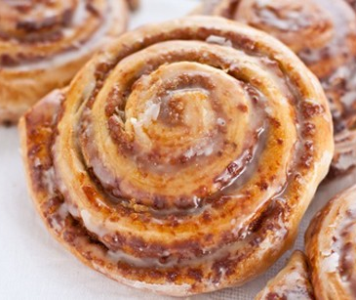
“Berliner”/”Pfannkuchen“ “Puddingbretzel” “Amerikaner” “Nussschnecke”
Filled with jam Filled with pudding. Frosting as a topping. Made with nuts.

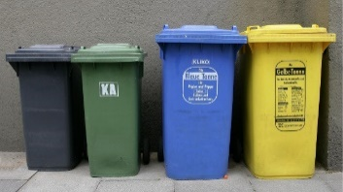
Separation of waste
In Germany there is a strict separation of waste in order to recycle. Depending on the region, they separate paper, organic waste (e. g. leftover food). On the right, you see the four main garbage cans.
Bin | What | Examples | Notes
Yellow bin/bag | Plastic, aluminium & packaging | Milk or juice cartons, foils, tins, plastic packaging, plastic bags, coffee to go cups, boxes fo take-away food | You should empty everything (e. g. in the black bin)
Blue bin | Paper & carton | Newspaper, paper, pizza boxes, carton | Bills or used tissues belong in the black bin
Brown bin | Organic waste (without packaging) | Food leftovers, fruit waste, potato peels, plant remains | Depending on the region merged with the black bin
Black bin | Residual waste | Clothing, cigarettes, hygiene products, diapers, broken glass, lightbulbs, dirty paper | (Everything that can’t be disposed of elsewhere)
Glass container | Glass (sorted by color: green, brown, white) | Glass bottles, wine bottles, glasses for food (e. g. from the supermarket | lids belong in the yellow bin
Special waste | e. g. electronic waste | Batteries Supermarket  LEDs hardware store

Pfand-System
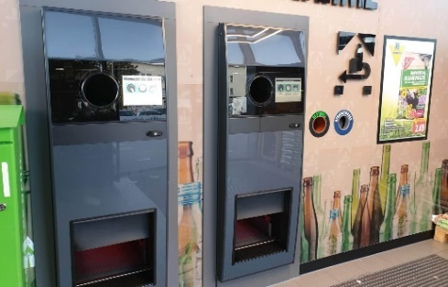
In Germany, there is a so-called Pfand-System – a bottle return system. When you buy certain products, you have to pay a deposit (the Pfand) for it (up to 25 cents). When you return the bottle, you get your Pfand back (if you throw it away, your deposit is lost). You can use the money for your shopping in the same supermarket.
Since 2022, all drinking bottles and cans have Pfand. Examples
You can return the bottles in nearly every supermarket. The picture shows you an example of the Pfand automats.

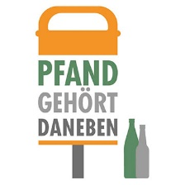
If you don’t have time to return a bottle, please leave it underneath the public bin, so homeless people can bring back the bottle and use the deposit. “Pfand gehört daneben” = Pfand belongs next to the bin.

Transportation
Public Transportation
There are several options for short-distance travelling in a city. Next to Uber or taxis, public transport is well developed in Germany. There are busses, overground (Straßenbahn/Tram), underground (U-Bahn), local railways (S-Bahn). Public transport is affordable and more common than taxis/uber since they are expensive, even for short-distance. Here are some information for the public transport:
- The timetables are fixed and you can check them via e. g. DB App (Deutsche Bahn), Google Maps or at the stations. They normally come on time and they won’t wait for you if you’re too late.
- In contrast to Jordan, there are bus stops or train stations. You normally can’t call a bus by standing in the street, you have to go the station.
- You can get daily, weekly or monthly tickets at the train station. Weekly tickets are cheaper than daily tickets. There are also different charges depending on your age or group (students pay less for example), so have a close look what suits you the most.
- In big cities, there are zonal tickets (e. g. Zone A for the city center). Make sure that you either buy a ticket for all the zones you’re travelling through.
- Make sure that you have a ticket and it is valid. The fees are very high (up to 80€) if you cannot show a validated ticket.
Bikes
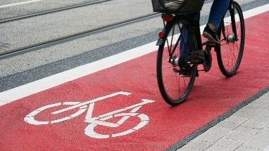
Bikes are very common in Germany as an alternative to public transports. Often, there are bicycle lanes especially for bikes where cars and pedestrians are not allowed to go on. They are either indicated by a red stripe, a sign on the floor or a street sign (or all). Some important rules:
- Make sure to stop at red lights. The fees are high.
- Make sure your bikes has a front and back light. If not, the police can charge you with money and car driver might not see you.
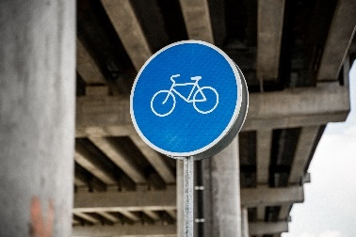
- Recommendation: Wear a helmet.
There are a lot of rental services. At https://swapfiets.de/ you can rent a bike for 15 € a month with repair service included. Another possibility is to use the bike sharing services such as NextBike https://www.nextbike.de/en/ . There are further stations in the city and with your application you can rent a bike at one station and give it back at another station (1€ per hour).
Scooter
In the big cities you will also find electric scooters such as Tier or Lime. In order to use these you need to install the application and connect it with your bank account. Indeed, the scooters are quite expensive (around 3 € for 20 minutes), and please be careful when using them.
Walking
Another common and popular possibility is walking. Streets and sidewalks are good and accessible. Make sure to not walk the bicycle lane.
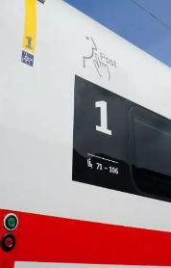
Long Distance Travels
The most common public transport is the train. The Deutsche Bahn is the main provider; therefore, it can be useful to install their application. Note that the tickets get more expensive the more short-term you buy it. If possible, try to buy your train tickets at least two weeks in advance, especially for long rides. To give you an example, a ticket from Mannheim to Berlin (5h) cost between 40€ to 140€ depending on the day of booking in advance. Some important information
- You normally don’t need a seat reservation in Germany, but it is recommended to do so fpr trains that are expected to experience a high capacity.
- There is “first class” and “second class”. The “first class” is quieter and more expensive. If you have a “second class” ticket, you are not allowed to be in the first class wagon.
- The Deutsche Bahn often has delays, changes the platform, the wagon sequence or seats. Therefore, it can be useful to have the application, to listen to the announcements at the train station and to keep an eye on the display boards.
You can also use car sharing platforms such as “Blablacar” or use the bus company called “Flixbus”. There is also the possibility to rent a car. There are a lot of providers such as “Sixt” or “Europcar”. Please familiarize yourself with the traffic rules in Germany and you need an international driving license. Compared to Jordan, prices are high.

Organization
Mobile Phone (+49)
A good and cheap way are prepaid cards. It is recommended to buy them in the supermarket, e. g. ALDI or LIDL. If you for example buy an ALDI card, you can download the application and book your preferred tariff on your own (e. g. ALDI TALK Package S: 3 GB in Europe and free calling and SMS in Germany for 7,99€). You can quit each month and top up your balance in the supermarket.
Finances
There are bank machines/ATMs nearly everywhere. Please check with your Jordanian bank how you can withdraw money in Germany. Furthermore, since Corona, you can pay nearly everywhere by card. Nevertheless, it is helpful to have some cash as not all cards work everywhere.
Medical Treatment
Medical treatment in Germany is considered as one of the best in the world. If you need to go to see a doctor, you can have look via Google Maps if there is someone around and either call them or use the open consultation. In case that you need to see a doctor on the weekend and for medical reasons it is not possible to wait until Monday, there is a medical on-call service. You can reach it by calling 116117 (same number throughout Germany).
In case of an emergency, go to a hospital emergency room (Notaufnahme) or call:
- 112 for fire/ambulance
- 110 for police

Security

Germany is a safe country. Nevertheless, pickpocketing and petty crimes happen, so please always check your belongings in crowded areas like train stations and never leave your bags unattended.
Make copies and scans of your most important documents (passport, visa) so that you can identify yourself, even if your bag got stolen.
Most places in Germany are safe day and night, but please ask locals if they would avoid certain places, they know best.
If you feel uncomfortable in a situation, try to leave immediately and don’t provoke.

Miscellaneous
- Germans do not use Whatsapp in academic contexts (only private), please use email or official ways of communication
- In Germany, you can throw the toilet paper in the toilet
- Windows in Germany have a tilting function – so don’t worry, the window will not fall! 😊
- Tap water is drinkable and everybody does it
- To see more about Germany, check out these Instagram accounts:
  - Deutschland_de – provides you with current information on corona, on politics and interesting things to know about Germany
  - Dw_travel – showing some insights where to go to in English Uyenthininh – a Vietnamese girl showing Germany trough her eyes in a funny way
  - Every city/town normally has its own account

Activities in free time

There are a lot of possibilities to fill your free time. For sure, they sometimes depend on the time you are traveling like for Easter or Christmas markets. But here are some general activities:

- There are normally offers for city walks in your city. You can also have a look if there are harbor tours depending on your city. You could also make a city tour to the surroundings cities. Also the small town can be quite nice, so do not only stick to big cities.
- Bike tours – there are a lot of bike paths, often alongside rivers. It is worth spending one day cycling and enjoying the nature!
- Hiking tours – be out in nature, fresh air is always a good idea!
- Visit castles – there is more than “Neuschwanstein” like the “Burg Eltz” and it can be quite interesting to get a closer look to the history.
- You could do an “Alpaca Hike” – you are hiking for a few hours and have your personal alpaca with you.
- Swimming lakes – there are a lot of natural lakes in nearly every region where you can spend a day at the lake and in the sun. Or rent a stand-up paddle and or a pedal boat, so you don’t have to go swimming.
- Thermal baths are also a quite popular activity in Germany. Spend your day relaxing in warm water that is also good for your health.
- You can go on a concert, musical, cinema or theater performance. This might also a great experience for challenging your German!
- Another nice experience are hip rope gardens (Hochseilgarten/ Kletterwald). Here you can spend a few hours climbing in the forest and enjoying the rope slide.
- For sure, there are also a lot of theme parks such as “Europapark” or smaller ones.
- If you are there in winter, you should try ice-skating! After some practice, it is a lot of fun!

Public Holidays
It is important to know the holidays as on these days, the supermarkets etc. are also closed like on Sunday. There are fixed and flexible holidays that vary in date each year. Moreover, some so-called “silent” holidays like All Saint’s or Good Friday. On these holidays, there is a prohibition of dancing, for instance.

Holiday | 2022 | Where | More information
New Year’s Day | Jan 01 | nationwide | No religious origin
Three King’s Day | Jan 06 | Baden-Wurttemberg, Bavaria, Saxony-Anhalt | Divinity of Jesus became visible through the Three Kings, often celebrated with Carolers
International Women’s Day | Mar 08 | Berlin | Origins in female workers movement at the end of 19th century
Good Friday (silent) | April 15 (flexible) | nationwide | Crucifixion of Jesus
Easter Sunday | April 17 (flexible) | nationwide | Resurrection of Jesus
Easter Monday | April 18 (flexible) | nationwide | Two disciples met God and confirmed the resurrection
Labour Day | May 01 | nationwide | Day for the workers, often politically organized demonstrations
Ascension Day | May 26 (flexible) | nationwide | Jesus rised into Heaven
Pentecost Sunday and Monday | Jun 5 +6 (flexible) | nationwide | Celebration of the Holy Spirit that connects the Christians
Corpus Christi | Jun 16 (flexible) | Baden-Wurttemberg, Bavaria, Hessen, Nord Rhine-Westphalia, Rhineland-Palatinate, Saarland (partly Saxony and Thuringia) | Catholical holiday, Jesus gave his disciples wine and bread (his livelier body) nowadays symbolized by hosts (wafers), often processions
Assumption Day | Aug 15 | Saarland (partly Bavaria) | Assumption of Mary into Heaven
World Children’s Day | Sep 20 | Thuringia | Awareness for rights and needs of children
Day of German Unity | Okt 10 | nationwide | Reunion of DDR and BRD
Reformation Day | Okt 10 | Brandenburg, Bremen, Hamburg, Mecklenburg Wester Pomerania, Lower Saxony, Saxony, Saxony-Anhalt, Schleswig-Holstein, Thuringia | Evangelical holiday, day when Martin Luther published his 95 theses on the door of the church of Wittenberg
All Saint’s Day (silent) | Nov 1 | Baden-Wurttemberg, Baviaria, Nord Rhine-Westphalia, Rhineland-Palatinate, Saarland | Catholic holiday, remembrance for the deceased and the saints
Day of Prayer and Repentance (silent) | Nov 16 (flexible) | Saxony | Evangelical Holiday, day of reflection and prayers for peace
Christmas Holiday | Dec 25 + 26 | nationwide | The Birth of Jesus
New Year’s Eve | Dec 31 | Not a holiday but everything closes at midday

