Application Form

Study Group Mobility

2019

University of Applied Sciences Magdeburg-Stendal,
GJU project office in cooperation with

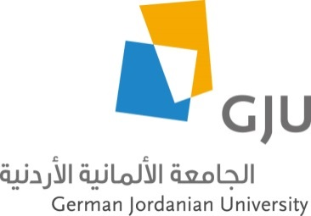

German Jordanian University (GJU)

1. Project Title

2. German Partner University

Name of German partner university
Name of faculty
Name of responsible professor
Number of participants (female/male)
Degree level / student´s field(s) of study

3. German Jordanian University

Name of school
Name of department
Name of responsible professor
Number of participants (female/male)
Degree level / student´s field(s) of study

4. Objectives

Primary aim and secondary objects; individual and scientific learning outcomes

5. Project products

Kind of products: exhibition, documentation, video, ... and form of presentation

6. Duration of the project and project end phase

Start - end of project; expected travel period; who intents to travel: GJU group or German group

7. Time schedule

Main activities and milestones

8. Project Description / Summary

(Max. 300 characters with spaces)

Signatures

Place: Date: Responsible professor GJU:

Place: Date: Responsible professor German University:

