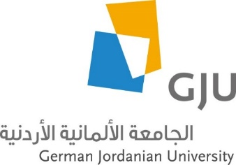
Schedule for GJU Summer Course Arabic Language and Culture
July 25 – August 14, 2021
Day | Sunday | Monday | Tuesday | Wednesday | Thursday | Friday | Saturday
Date | 25.07. | 26.07. | 27.07. | 28.07. | 29.07. | 30.07. | 31.07.
09:00 - 10:30  11:00 - 12:30 | Welcome meeting  (Lunch) | Arabic | Arabic | Arabic | Arabic | Trip to Wadi Rum and Petra | Trip to Wadi Rum and Petra
after 13:30 |  | Round trip in Amman |  | Cultural/political education in Amman*
Date | 01.08. | 02.08. | 03.08. | 04.08. | 05.08. | 06.08. | 07.08.
09:00 - 10:30  11:00 - 12:30 | Arabic | Arabic | Arabic | Arabic | Arabic | Trip to Jerash
after 13:30 |  | Cultural/political education in Amman |  | Cultural/political education in Amman*
Date | 08.08. | 09.08. | 10.08. | 11.08. | 12.08. | 13.08. | 14.08.
09:00 - 10:30  11:00 - 12:30 | Arabic | Arabic | Arabic | Arabic | Arabic | Trip to Madaba and Dead Sea
after 13:30 |  | Cultural/political education in Amman |  | Cultural/political education in Amman | Farwell gathering  (Snacks)

*Cultural/political education in Amman: Foundations, German Embassy, Organizations etc. - will be specified soon.

