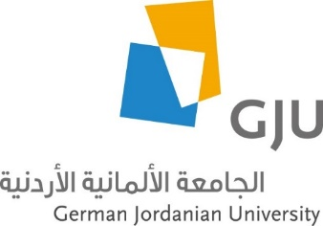
Schedule for Learn Arabic and Discover Jordan - Summer Course
August 1st – August 21st, 2021
Day | Sunday | Monday | Tuesday | Wednesday | Thursday | Friday | Saturday
Date | 01.08. | 02.08. | 03.08. | 04.08. | 05.08. | 06.08. | 07.08.
09:00 - 10:30  11:00 - 12:30 | Welcome meeting and campus tour  (Lunch) | Arabic | Arabic | Arabic | Arabic | Day trip to Jerash | Leisure
after 13:30 |  | Guided city tour of Amman |  | Cultural/political education in Amman* | Cooking class
Date | 08.08. | 09.08. | 10.08. | 11.08. | 12.08. | 13.08. | 14.08.
09:00 - 10:30  11:00 - 12:30 | Arabic | Arabic | New Year Holiday:  Trip to Umm ar-Rasas and Kerak Castle | Arabic | Arabic | Overnight trip to Wadi Rum and Petra
after 13:30 | Round trip in Madaba | Cultural/political education in Amman* |  | Intercultural training | Cultural/political education in Amman*
Date | 15.08. | 16.08. | 17.08. | 18.08. | 19.08. | 20.08. | 21.08.
09:00 - 10:30  11:00 - 12:30 | Arabic | Arabic | Arabic | Arabic | Arabic | Trip to the Dead Sea
after 13:30 |  | Cultural/political education in Amman* | Cultural/political education in Amman* | Cultural/political education in Amman* | Farwell gathering  (Snacks)

*Cultural/socio-political stakeholders visit: Foundations, German Embassy, Organizations etc. - will be specified soon.

