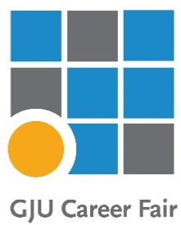
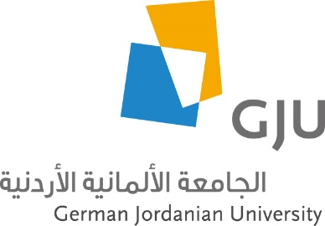

DI-TECH - Deanship of Innovation, Technology Transfer and Entrepreneurship

14th GJU Career Fair 2025
Event Report

The 14th Annual GJU Career Fair was organized by the Deanship of Innovation, Technology Transfer, and Entrepreneurship (DI-TECH) on May 13, 2025.
The event was a great opportunity to connect companies with our graduates and students.
The 14 GJU Career Fair, held on Madaba Campus on May 13, 2025, marked the biggest event of its kind in Jordan to date. Beyond expectations, a total of 90 companies attended the fair and made use of the opportunity to profile their businesses and exchange career opportunities with GJU students and participants. The logistics and coordination of the event was successfully managed by the DI-TECH team despite difficult and, at times, adverse regional conditions.

The German dimension of the university was also evident through the participation of the GJU Vice President for International Affairs, DI-TECH Industry Partnership Coordinator, and staff from administration and academics. A significant number of the participating companies have business links to Germany in form of contracts, subsidiaries and associations. Besides “internationals” (e.g. E & Y, Deloitte, DHL, Royal Jordanian, …), a number of other enterprises, as representatives reported at the career fair, have traditional established economic interests and markets in Germany. Known partners such as the GIZ or newcomers to the GJU Fair such as Phoenixcontact (HQ Germany, Middle East Branches) voiced positive feedback about the organization and overall character of the event. Phoenixcontact, as an example, showed a keen interest to recruit students and attract candidates for mainly for Dual Studies. DHL, also featured during a company-student online conference a few weeks ago, remains a priority employment/internship profile for GJU.

Overall, comments on the high motivational level of students and their in-depth preparations prior to the event were voiced. Well trained communicators and company representatives encountered students knowledgeable of the concerned company activities. Visibly, the informational exchanges (contacts, cv) were in hard copy form and electronic. QR code-based group chats facilitated timely updates and professional networking. As the organizer, DI TECH is poised to become a major resource option for events of this kind at a national and regional level. German observers noted that lessons learned will also serve to prepare additional marketing actions for German companies to attend/register ahead of time for the next Career Fair. In addition, the fair could be opened to German companies based in the MENA region.
Venue:
The event took place at the Sports Hall, which proved to be an ideal venue, adding significant value to the overall structure and organization of the career fair.

Registration & Participation:
The registration process for the career fair was conducted through a tailor-made website developed and maintained (Information System and Technology Center).
Under the direct supervision of the Dean of Innovation, Technology Transfer, and Entrepreneurship, Dr. Nidal Al-Shawawreh, and the follow-up of the Head of the Career Fair Committee, Dr. Hamza Al-Majali, members from various university departments participated in planning and organizing the Career Fair.

Among the committee members, efforts related to company registration, assistance, and the completion of all necessary procedures were managed by Dr. Hamza Al-Majali, Esra’a Al-Zou’bi. Logistics responsibilities were handled by Eng. Hala Al-Eyadah. Additional support was provided by colleagues from DI-TECH, including Lama Fadel, Ghena Hatem, and Morad Haimour and Eng. Sondos Al-Mashaileh .

Total number of participating companies: 90 company representing variable industrial sectors in Jordan, Germany & MENA region. A list of companies is included in this report. (Table 2)
This year ,It was very noticeable that many of the company representatives who participated in the career fair were GJU graduates.

Total number of visitors: approx. 1500 visitors (students, graduates and faculty members)
Payment & Financial:
The event was sponsored according to the following details in the following table:
Table 1: Sponsors

Company Name | Sponsorship Kit | Amount
Bank El Etihad | Gold | 3000 JD
Alfanar | Gold | 3000 JD
German Energy Academy in Jordan | Silver | 2000 JD

Since this event is self-sustained in expenses, the participation fees for companies were 200 JOD for the booth, with special rate of 150 JOD for the Dual Studies partner companies. Total was JOD, including the sponsorship amount.

Total expenses of the event were 7550 JD.

Company Assistants & Students Employees:
Students from the Innovation Club actively assisted in organizing the event and played a vital role on the day of the Career Fair.
Approximately 110 students were selected as ushers, with each assigned as a Company Assistant to one of the participating companies. It is worth noting that most companies provided positive and enthusiastic feedback regarding their assigned assistants.

Career Fair Handbook
As in previous years, we have published a career fair handbook. Additionally, this year, an electronic version of the handbook was posted on the career fair website that all visitors to the exhibition can obtain about made available on the Career Fair website, allowing all visitors to access detailed information. The goal is to provide information about the participating companies, their profiles, the specializations they are interested in and what they had to present at the career fair.
Career Fair & Dual Studies:
34 of our Dual Studies partners participated in the career fair this year. The fair was a good opportunity for the Dual Studies company acquisition team to meet potential partners and introduce the program to them and conduct interviews with dual studies students.

The analysis of career fair
Visitors’ survey

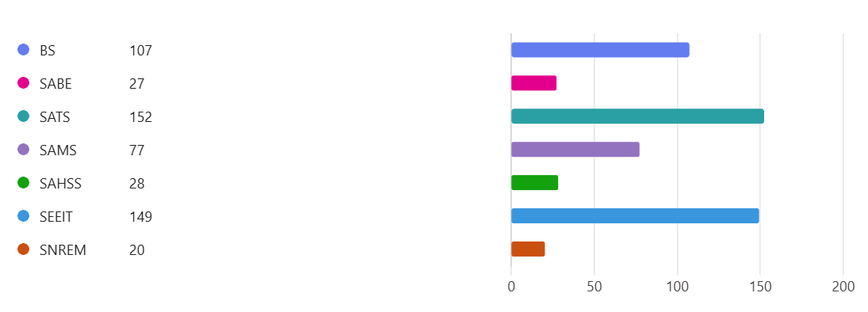

Figure 1:
The chart shows that BS, SATS, and SEEIT have the highest number of graduates attending the career fair, while SNREM, SABE and SAHSS have the lowest. This suggests strong engagement or larger programs in BS, SATS, and SEEIT. To increase participation, targeted outreach to schools with lower numbers could be beneficial.

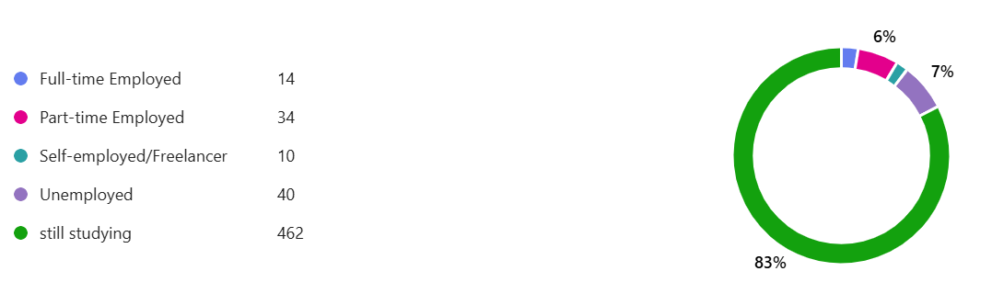

Figure 2:
The chart indicates that 83% of participants are still studying, while 7% are unemployed. A small portion is employed full-time (3%), part-time (6%), or self-employed (2%). The majority being students suggests this event is mainly attracting current students rather than recent graduates or job seekers.

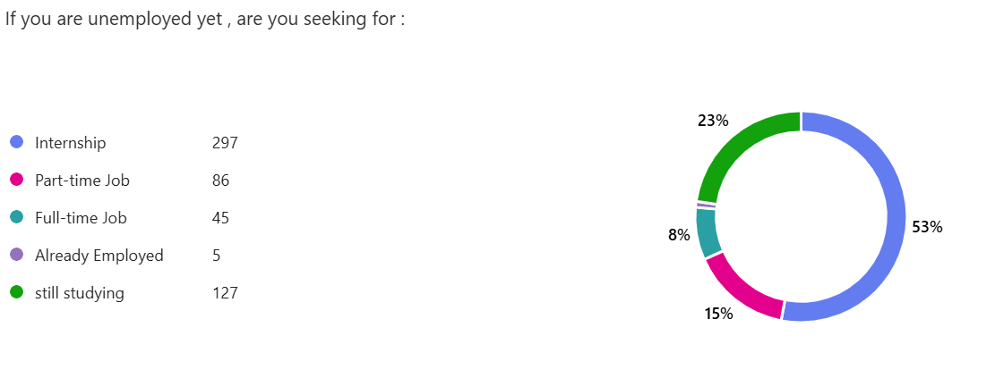

Figure 3:
The chart shows that 53% of respondents are seeking internships, while 23% are still studying and not actively looking for jobs. Among those seeking employment, 15% are interested in part-time jobs, and 8% in full-time roles. This suggests a high demand for internships, likely from students aiming to gain experience.

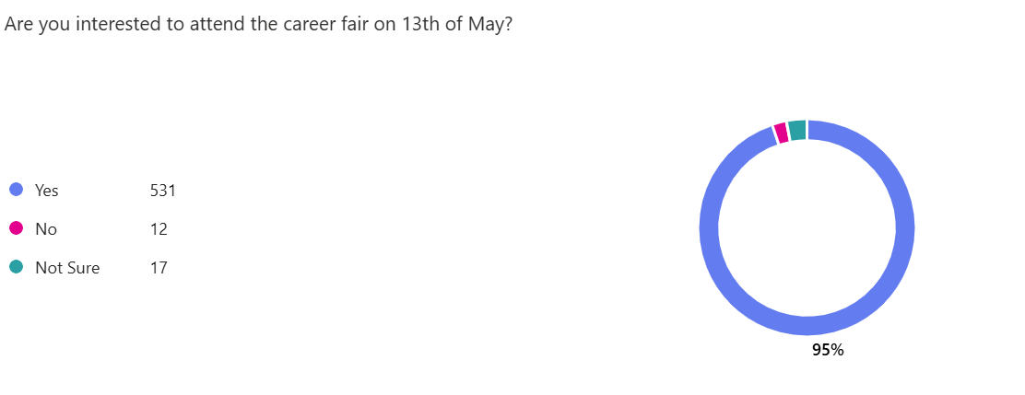

Figure 4:
This chart shows the level of interest in attending a career fair on May 13th. An overwhelming majority (95%) responded “Yes," while 3% are "Not Sure," and 2% answered "No. This indicates strong interest in participating in the event, with only a small percentage undecided.
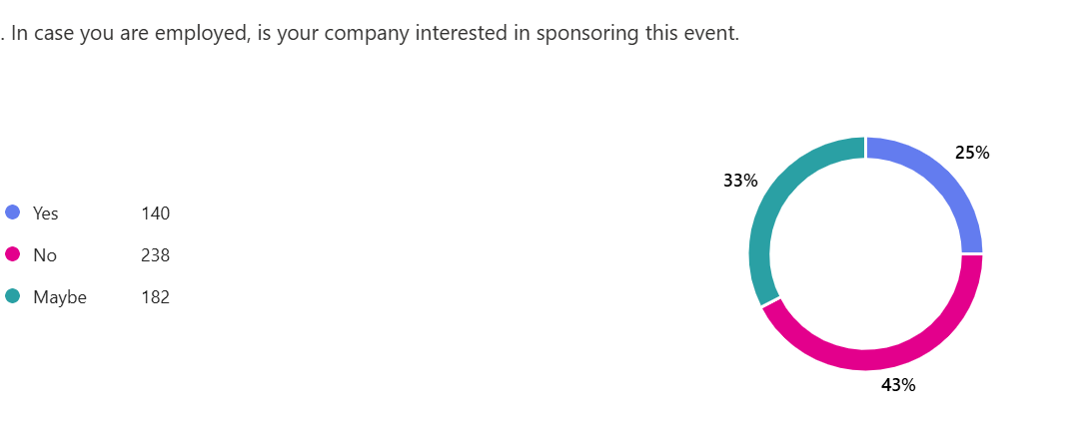

Figure 5:
This chart shows survey results regarding company interest in sponsoring an event.
The majority (43%) responded "No," while 33% responded "Maybe," and 25% responded "Yes." This indicates that interest in sponsorship is generally low, with uncertainty being the second most common response.

Recommendations:

1. Improve the payment method as some companies found the bank transfer/deposit process time consuming.

2. In this career fair, the number of graduates who attended was higher than in previous years; however, the number remains relatively low. If possible, we should find a way to encourage alumni to participate more actively in the career fair.

3. We are continuously updating the company data, especially since we have contacted many employees, many of whom were either on leave or have left their positions. This has taken us a considerable amount of time to reach the relevant person in each company, and we need to streamline this process.

4. Given the significant increase in company interest to join the 14th Career Fair, we strongly recommend considering a larger venue than the current one consider a larger venue than the current one to ensure a more efficient and organized experience for all participants.

5. It is recommended that the authority select the responsibility for selecting the organizing committee for the Career Fair be entrusted to the Deanship of Innovation, Technology Transfer, and Entrepreneurship, as it possesses the most comprehensive knowledge of the individuals actively engaged in the planning and execution of the event.

List of Companies Participated in the 14th GJU Career Fair 2025. Table (2)
NO | Number of Sponsor Companies | Number of Participated Companies | Number of Dual Studies Companies | Guests Of Honor
NO | 3 | 47 | 34 | 9
1 | Bank El Etihad (Gold Sponsor) | Language Generation Center | DHL | Military Credit Fund
2 | Al Fanar (Gold Sponsor) | Maaden International Recycling | Royal Jordanian Airlines | Jordan Ahli Bank
3 | GEA (Silver Sponsor) | KPMG | Hikma | JEDCO
4 |  | ABS | Leaders center | Business Development Center
5 |  | Arab Center for Engineering Studies | Chalhoub Group | Estarta
6 |  | Jordan Bromine Company | Menacom | Twelve Degrees Design
7 |  | PwC | Petra Engineering Industries Company | FNF
8 |  | Arab Bank | MAS Kreeda Al-Safi | The kitchen
9 |  | Teeba/ Almarai | Pine Tree Company | Ibrahim Siyam Industrial Group
10 |  | JEDCO | Estarta Solutions
11 |  | MLB for Studying Abroad & Modern Language Center | Alawneh Exchange
12 |  | Lafarge Cement Jordan | Jabal Amman Publishers-Kutubee
13 |  | Morgan International Jordan | Umniah
14 |  | Chain Reaction | Orange Jordan Company
15 |  | Capital Bank of Jordan | Bank al Etihad
16 |  | Bank ABC | ALV
17 |  | ESAL | Arabian Consert Suplly Company - Lafarge Jordan
18 |  | D.eriv | GIZ
19 |  | Crystel | Newton Insurance
20 |  | Katalynk | Ernst & Young (EY)
21 |  | Techalamal | Housing Bank
22 |  | Loyalty Support Services | Fine Hygenic Holding
23 |  | Dar | Gulf Insurance Group - Jordan "GIG-Jordan"
24 |  | Phoenix Contact | Al Ameed coffee company
25 |  | PROTECH | Ingot Financial Brokerage LTD
26 |  | Amman Champer Industry | Nabil foods
27 |  | GESCO | Kasih Food Industries
28 |  | GIZ/ ZMe Project | Jordan Ahli Bank
29 |  | Ejada | Ipsos
30 |  | Nasco Company | Estarta
31 |  | Deanship of Graduate Studies | Twelv Degreed Design
32 |  | Deloitte Consulting | FNF
33 |  | Bank of Jordan | The kitchen
34 |  | Jordan Islamic Bank | Ibrahim Siyam Industrial Group
35 |  | Sayegh Group
36 |  | FREUDENBERG-VILEDA-JORDAN
37 |  | Alfanar
38 |  | JCB
39 |  | GEA
40 |  | Global Educational Excellence (GEE)
41 |  | Abu Sheikha Exchange
42 |  | JORAMCO
43 |  | Dar Aldawa
44 |  | Business Development Center
45 |  | Military Credit Fund
46 |  | JODDB
47 |  | Business Development Center

