Deanship of Innovation,
Technology Transfer and Entrepreneurship
Alumni Reunion 2025 Report

Introduction:
The GJU alumni reunion is an annual event organized by the Deanship of Innovation, Technology Transfer and Entrepreneurship (DI-TECH@GJU) to emphasize GJU’s engagement with its graduates and support their professional growth.  GJU has more than 9000 graduates; many of them are working abroad. The objectives of this event is to:  - Link graduates together and with the university community  - Share success stories to promote employability, innovation, and entrepreneurship  - Explore potential partnerships with graduates’ employers in relation to training, research, and entrepreneurship  - Keep graduates updated about and engaged in GJU strategies and plans.  - Build partnerships between GJU and national and international organizations through our graduates | 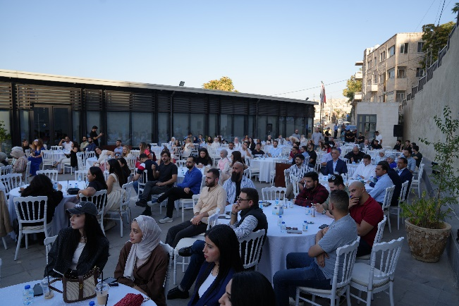
Event Overview

Venue and time: GJU campus Jabal Amman, 2nd of August 2025
Event preparation and organization:
A committee from different GJU departments has been nominated to manage the event, from designing a sponsorship kit to contacting alumni and finally managing and preparing the venue of the event. A group of students from the innovation club were joined to help with the registration and throughout the event. The social media channels have been used to spread out the invitation to the event to alumni as maximum as possible, and the existing database of alumni from the registration office has been used as well. The event is based on a group of speeches, interactive sessions, and a networking dinner.

Attendance Groups
1 | Alumni include Managers and co-founders for companies in Jordan, Mena Region as well as internationally. | 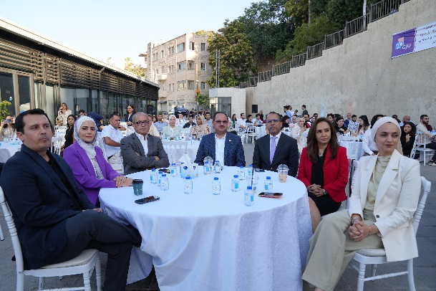
2 | Guests from the Plan International and the Jordan Enterprise Development Corporation.
3 | presentative Alumni club in Germany.
4 | GJU event committee, members from the innovation club, GJU Staff and Deans.  With attendances between 250 to 300 people.

Financial Aspects:

The DI-TECH asked reservations to cover different costs in this event , and some the sound system, speakers, the big digital screen and decoration. The event included a dinner which cost 15 JD per person.

Event Highlights

The event started with a group of speeches from the president: Prof. Al-Halhouli, and the DI-TECH Dean Dr. Alshawawreh as well as the two event guests: Ms. Sima Oran (Jordan Enterprise Development Corporation) and Ms. Hamida Jahamah (Plan International). In addition Mrs.Alumni Keynote: Ayda Abdo, Director of Human Resources, The Royal Hashemite Court, Director of The Royal Heritage and The Royal Automobile Museum Those speeches have addressed the development of the GJU through the last 20 years, and the collaboration with different active institutions in Jordan. The event contains two main sessions from the alumni: the spotlight and a panel session. At which a group of alumni discussed their success stories and addressed the process of establishing their own companies, and how both experiences in GJU/Jordan and one year in Germany assisted them through their success journey.

The panel session addressed different topics related to entrepreneurship, at which the participants discussed their journey to be establishing their own companies and being active partners within the industrial sectors in both Mena and European regions.

The reunion contains rich ideas, success stories, and directions for recent graduated students and opens doors for different kinds of collaboration for different departments and sectors within GJU that shall lead to improving the overall German Jordanian university ranking.

Feedback and Testimonials
Based on the feedback survey, emails were the most accessible medium for alumni, as 55% of respondents learned about them through their emails.
90% of those in attendance said the event was beneficial to them. It provided them with an opportunity to reestablish their connections with friends and coworkers. They talked about how important it is to have a wider variety of events and to increase networking opportunities at the event. They give networking an overall score of 75%, ranging from outstanding to good. They recommend holding more participatory sessions and debating trending subjects in science and economics through upcoming events.
The overall evaluation scores demonstrate the success of the event. Alumni request that this be scheduled regularly.

Challenges:
- Establish a regular content-based communication platform (not only public relations) for alumni regards employability/ ranking.
- Design and develop a methodology to attract German/ International companies and open a door for companies to join the GJU Business Hub (Science Park which is an internal working title of GJU future plan) over the alumni network.
- To obtain more information about the quality aspects of employment (satisfaction, future current development, social aspects, and working in the action field of educational certifications etc).

Conclusion and Recommendations
- Create a generic alumni future function that illustrates how reunions affect employability and provides both general quantitative and qualitative information for GJU ranking.
- Intensify meetings with graduates to discuss increasing future cooperation.

