GERMAN JORDANIAN UNIVERSITY
School of natural resources engineering and management
Water and Environmental Engineering Department

Surveying Laboratory

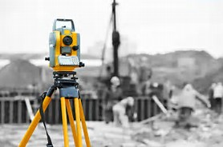

Table of Contents
- A GUIDE TO LABORATORY REPORT WRITING………………………………………….
- CONTENT OF REPORT SECTIONS………………………………………………………….
- INTRODUCTION ………………………………………………………………………………

- Methods of measuring horizontal distances……………….……….......................................

- Distance with obstacles………………………………………………………………………….

- Horizontal taping over sloped ground………………………………………………………….

- Levelling…………………………………………………………………………

A GUIDE TO LABORATORY REPORT WRITING

Introduction

This guide is designed to be used in preparing laboratory reports for all courses. Though, this guide contains useful information can be used in writing any engineering laboratory report.
This guide describes the structure of a good engineering report, explain the need for each section, and outlines the contents for these sections. It introduces some standard conventions and rules for writing reports of professional quality. Reports will be reviewed on the basis of instructions contained in this document, and grades will be strongly affected by the quality of reports.

Laboratory Notebook

An essential requirement of engineering experimentation is that a laboratory notebook be maintained. This notebook should contain dated entries for every laboratory session, which include all the notes and sketches made during the session, all the data recorded, and any other observation relevant to the laboratory session. Professional engineers and scientist should make it a standard practice to maintain such notebooks. There are several reasons to do so. A complete and updated notebooks permit easy access to information, eliminates bias in recording and interpreting data, establishes a time line that is vital for patent applications, and helps in preparation of reports.

Every student is required to maintain a laboratory notebook. The following systems will be adopted in each laboratory course: Students maintain one laboratory notebook. At the end of each session, the student shows the book to the TA (Teaching Assistance), who inspects it, make any necessary suggestions for improvement, and records the inspection on a grade sheet. The student turns in the notebook for final evaluation with the last report in the semester.

Structure of Engineering Reports

Engineering reports may be classified according to whether they are complete engineering reports on a project, short reports on one or more tests, or short reports on one or more techniques. The structure of engineering reports has evolved to serve the needs of the varied readership. For more information about the evolution of engineering reports consult Tuve and Domholdt (1966).

Engineering report should always be written for the convenience of the reader. Thus, for example each section of the report should be headlined and the sections should be arranged in an appropriate easily-understood sequence. In the context of the course for which it is written, the laboratory report serves to describe what you did during the laboratory session, how you manipulated the raw data, and what your conclusions are. While it may seem logical to you to write a report in chronological or historical sequence, such an approach is not the most useful for your readers, who would find such a report difficult to scan for the items of interest. Think of the document as proof that you understand what you did and that you can apply it in practical situations. It is a performance document.

By the time you take several laboratory courses, you are expected to understand both format for a full engineering report and some of the variations that are appropriate in different contexts. The engineering reports described above typically contain several (but not necessarily all) of the following sections, in the order listed:

- Title Page
- Table of Contents
- Introduction (Background Information)
- Statement of Objectives
- List of Equipment used
- Procedure
- Data
- Analysis of Data
- Discussion of Results
- Conclusions
- Recommendations
- References

Content of Report Sections

The content of each of the sections in an engineering report is described in the following pages. Most of the descriptions are general enough to be valid for all engineering reports.

1. Title page
Information on the title page should be balanced and centered neatly. It should consist of
- A brief but informative title that describes the report
- The name (s) of the author
- The dates (s) the experiment was performed, and the date the report was due
- The laboratory section number and the name of the Teaching Assistant
- The names of other group members who were present for the experiments

2. Table of Contents
A table of contents should be placed following the title page if the report is long (more than ten pages). It should list each section of the report and the corresponding page number.

3. Introduction and Background Information
The appropriate information for the introduction varies with the kind of report. Most introductions provide the reader with the necessary background to help put the objectives and results in a proper perspective. When necessary, previous related work is described. If the report is on several short experiments, the overall purpose and background of the group of experiments should be described first, followed by the necessary information for group of experiments should be described first, followed by the necessary information for each of the experiments. In this case, the introduction should not be a mere collection of material on each, but should be written using connected paragraphs with clear transitions between ideas and information.

4. Statement of Objective
State the objective (s) of the experiment concisely, in paragraph form. The laboratory manual or instruction sheet will help here. The fact that experiments in laboratory courses are being used to educate students is a secondary objective, and should not be stated in the report. The section should inform the reader precisely why the project was undertaken.

5. List of Equipment Used
List all the equipment and materials used in the experiment. Include identifying marks (usually serial numbers) of all equipment. This is a safeguard that allows you to trace faulty equipment at a later date, if necessary. The reader must be able to connect each item in this section to the item in the Description of Experimental Setup section.

6. Procedure
Detail the procedure used to carry out the experiment step. The laboratory manual of instruction sheet, together with the instructions given to you by the laboratory instructor, will be of help here. Sufficient information should be provided to allow the reader to repeat the experiment in an identical manner. Special procedures used to ensure specific experimental conditions, or to maintain a desired accuracy in the information obtained should be described.

7. Data
All the pertinent raw data obtained during the experiment are presented in the section. The type of data will vary according to the individual experiment, and can include numbers, sketches, images, photographs, etc. All numerical data should be tabulated carefully. Each table, figure and graph in report must have a caption or label and a number that is referenced in the written text. Variables tabulated or plotted should be section should contain only raw information, not results from manipulation of data. If the latter need to be included in the same table as the raw data in the interests of space or presentation style, the raw data should be identified clearly as such.

8. Analysis of Data
This section describes in textual form how the formulaic manipulation of the data was carried out and gives the equations and procedures used. If more than one equation is used, all equations must carry sequential identifying numbers that can be referenced elsewhere in the text. The final results of the data analysis are reported in this section, using figures, graphs, tables or other convenient forms. Sample calculations and details of calculations and analyses should be placed in the Appendix, and the reader directed to the appropriate section of the Appendix for that information. The end result of the data analysis should be information, usually in the form of tables, charts, graphs or other figures that can be used to discuss the outcome of the experiment or project. This section must include statements about the accuracy of the data, supported where necessary by an error analysis. Details of the error analysis are to be included in the Appendix.

9. Discussion of Results
This section is devoted to your interpretation of the outcome of the experiment or project. The information from the data analysis is examined and explained. You should describe, analyze and explain (not just restate) all your results. This section should answer the question what do the data tell me? Describe any logical projections from the outcome, for instance the need to repeat the experiments or measure certain variables differently. Assess the quality and accuracy of your procedure. Compare your results with expected behavior, if such a comparison is useful or necessary, and explain any unexpected behavior.

10. Conclusions
Base all conclusions on your actual results. Explain the meaning of the experiment and the implications of your results. Examine the outcome in the light of the stated objectives. Seek to make conclusions in a broader context in the light of the results.

11. Recommendations
This section is sometimes combined with the conclusions to make the report more readable. The section should address extensions, changes or modifications of future experiments and the reasons why these suggestions are made. Several issues can be raised Do the results suggest the need for other experiments? If so, what are the new objectives? Is the present procedure inadequate or incorrect? If so, how should it be changed? Does it call for a different technique of different instrument? Is the objective itself reasonable?

17. References
Using standard bibliographic format (see Hacker, 1992), cite all the published sources you consulted during the conduct of the experiment and the preparation of your laboratory report. List the author (s) title of paper or book, name of journal, or publisher as appropriate, page number (s) if appropriate and the date. If a source is included in the list of references, it must also be referred to at the appropriate place (s) in the report.

Language and Style
As with all other modes of communication, engineering reports are most effective if the language and style are selected to suit the background of the principal readers. Engineering reports are judged not only on the technical content, but only clarity, ease of understanding, word usage and grammatical correctness. Making an effort to improve your writing will pay off in better grades and in your professional advancement after graduation.
Reports should be written in the third person, past tense, in an impersonal style. The entire report should be written in textual form; don't expect figures or equations to serve where sentences and paragraphs are needed. As you edit your report, delete unnecessary words, rewrite unclear phrases and clean up grammatical errors. Use separate headings for each section. Allow space between sections. Place tables, schematics, or graphs logically, label and number them clearly, and execute them neatly. Aim for a clear, easy-to-read, professional-looking report.

References
Hacker, D. A Writer's Reference, Bedford Books of St. Martin's Press. Inc., Second edition, 1992.
Tuve, G. L., and Domholdt, L. C., Engineering Experimentation, McGraw-Hill Book Company, 1966.
Acharya, M., Bergmann, L. and Way, J., A Guide to Laboratory Report Writing, Illinois Institute of Technology, 1993.

INTRODUCTION

Surveying or land surveying is the technique, profession, and science of determining the terrestrial or three-dimensional position of points and the distances and angles between them. A land surveying professional is called a land surveyor.
These points are usually on the surface of the Earth, and they are often used to establish maps and boundaries for ownership, locations like building corners or the surface location of subsurface features, or other purposes required by government or civil law, such as property sales.
Surveyors work with elements of geometry, trigonometry, regression analysis, physics, engineering, metrology, programming languages and the law. They use equipment like total stations, robotic total stations, GPS receivers, retroreflectors, 3D scanners, radios, handheld tablets, digital levels, subsurface locators, drones, GIS and surveying software.
Surveying has been an element in the development of the human environment since the beginning of recorded history. The planning and execution of most forms of construction require it. It is also used in transport, communications, mapping, and the definition of legal boundaries for land ownership. It is an important tool for research in many other scientific disciplines.

METHODS OF MEASURING HORIZONTAL DISTANCES

In topographical surveys, you measure distances along straight lines. These lines either join two fixed points or run in one direction starting from one fixed point. They are plotted in the field with pegs, pillars or ranging poles.

-There are many good ways to measure distances. The method of measurement you use will depend on several factors:
- the accuracy of the result needed.
- the equipment you have available, to use.
- the type of terrain you need to measure.

Methods of measuring with accuracy:
Pacing -- accuracy 1 / 100 (1.0%)
Measuring Wheel-- accuracy (Standard) 1 / 2,000 (0.05%)
Taping -- accuracy (Standard) 1 / 5,000 (0.02%)

In this experiment we will try to measure the same distance in different ways in order to compare them with each other and find the most precise method in measuing direct horizantal method .

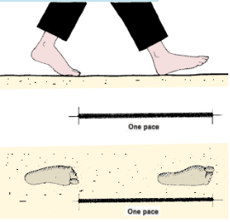
1.Measuring distances by pacing:
you should know the average length of your step
when you walk normally. This length is called your
normal pace. Always measure your pace from the
toes of the foot behind to the toes of the foot
in front.

To measure the average length of your normal pace (the pace factor, or PF):
- take 100 normal steps on horizontal ground, starting with the toes of your back foot from a well-marked point, A, and walking along a straight line.
- mark the end of your last step with peg B, at the toes of your front foot.
- measure the distance AB (in meters) with, for example, a tape and calculate your pace factor PF (in metres) as follows:
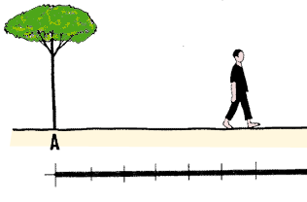  Walk 100 paces |  | PF = AB /100  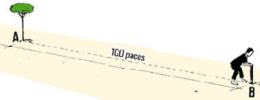
Example
If for 100 paces, you measure a distance of 76 m, then your pace factor is calculated like this: PF = 76 m / 100 = 0.76 m

2.Measuring horizontal distances with tapes:

Measuring tapes are made of steel, metallic cloth or fiberglass material. They come in lengths of 10 to 30 m or more. They are usually marked at 1 m intervals, with the first and last meters graduated in decimeters and centimeters. They are wound into a case, with a handle for rewinding. Tapes can present some problems. Steel tapes can easily become twisted and break. Cloth tapes are less precise than the others, since they often vary slightly in length.
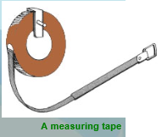

Notes in measuring: you should pull tapes tight, so that they do not sag, especially when you are measuring long distances. But, you should avoid over-stretching them (especially fiberglass tapes), since this could lead to errors.

3.Measuring horizontal distances with a measuring Wheel:

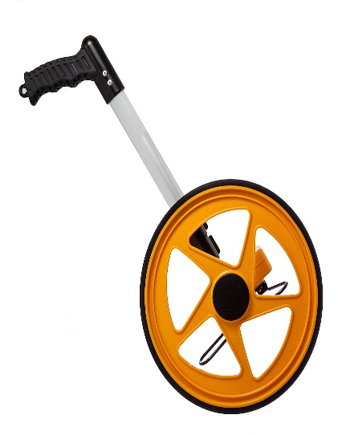

The distance measured by the wheel =
(reading of the wheel /10) m

Note: the radius of the wheel is to be (320mm)

A measuring Wheel

LAB SHEET

Student name: …………………….
ID: …………………………………

1. Construct your distance by pacing 100 paces marking the starting point and the end point in order to measure it.
2.use a tape of suitable length and measure that distance in meters.
3.remeasure the same distance using the measuring wheel.
4.measure your pace length directly using a tape for three times then take the average.
5.copmare the true length of you pace to the ones measured in steps 3&4. (Which method is more precise the tape /Wheel)?
6. Find the correct tape length, knowing that the actual length exceeds the nominal length by 0.015 m. Assume that the tape has a cross-sectional area equal to 0.04 𝑐𝑚2 and weighs 0.01 𝑘𝑔/𝑚. The temperature on the day of measurement was 19℃. Ignore the effect of pull. Comment on the support system you provided for the tape.

Pace length (m) | Measured distance(m) | Method used
 |  | Tape
 |  | Wheel

True pace length =

Distance with obstacles:

Sometimes we need to measure a distance using a measuring tape, with the sole problem of having a large obstacle in the way.
In order to do that we use trigonometric laws.
Method 1:
In order to find the distance between points A and B, we do the following:
1.We assign two lines between points A and B and a known point E.
2. We assign point F on line AE and point G on line AB using orientation. Both points should be aligned.
3. We measure the distance between point F and G.
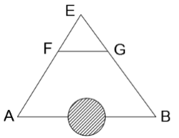

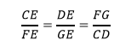
4. Use the laws of trigonometry in order to find distance AB.

- If the distance AB is too long, we can divide it into three parts, two of which are of a known length (AC and DB), and then the same steps in method 1 are followed in order to find the length of the third part CD. See Figure below. After finding the distance of the third part all lengths are added in order to find the total length.
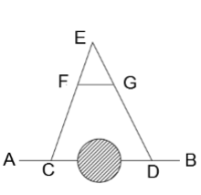
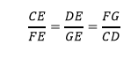

Method 2:
In case the obstacle was a river as shown in the figure below, we do the following:
1. We assign two points (C and D) on the line whose distance we need to measure (AB).
2. We connect a line between points C and E perpendicular at line AB.
3. Using orientation, we assign a point on line EB called F, and we draw a line from F perpendicular at AB.
4. We find lengths CE, DF, and CD using taping.
5. Using laws of trigonometry, we find distance CD, and then we find AB.

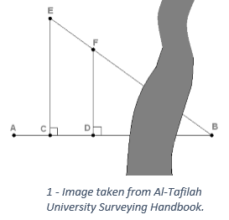
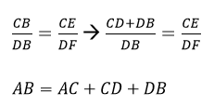

Orientation:
We use orientation in order to set three points on a straight line.

In order to do that, we need three staffs, as shown.
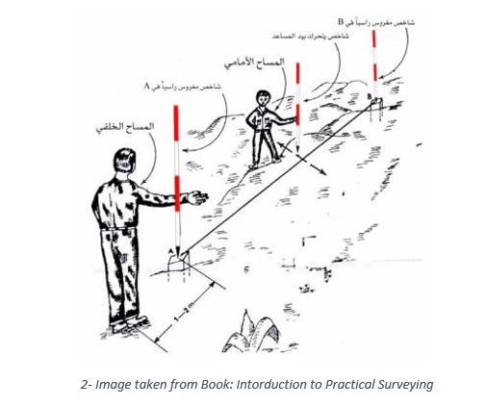

1.Two surveyors stand at the two ends of the straight line in question (A and B).
2. A third surveyor sets up the staff so that it is aligned with points A and B.
3. A fourth person stands behind point A by 1 or 2 meters in order and crouches in order to make sure the three points are aligned.

LAB SHEET

Student name: …………………….
ID: …………………………………

Construct the following cases on site then find the required distance(AB) showing the steps you followed:
Show the distance for each side

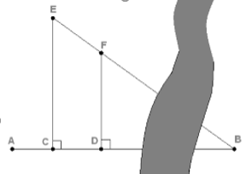

Case 1 Case 2

Horizontal taping over sloped ground:

In this lab, we will practice how to measure distances over sloped ground.
1. On steep slopes, where a 30 𝑚 length cannot be held horizontally without holding it above the shoulder, “breaking tape” procedure is used.
2. Horizontal distances of all segments are measured and added up to give the entire distance.
3. Taping downhill is more preferable than taping uphill, since the tape is more steady.

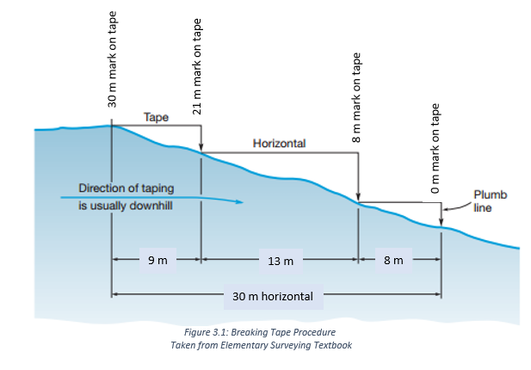

Equipment:
- Tape
- Pins
- Poles
- Plumb bobs
Procedure:
1. Mark points A and B at the beginning and end of the distance to be measured. Measuring is performed downhill.
2.The rear tape-person stations himself/herself at point A. The other tape-person forwards until he/she reaches a maximum distance that enables him/her to hold the tape below the chest area (9 𝑚 in Figure 3.1).
3.The plumb bob is used in order to help read the measurement, as in Figure 3.2.
4.A pin is inserted in the ground at the end of the first distance.
5.The rear tape-person moves to the end of distance one and holds the pin in place, and records the tape reading.
6.Steps 2, 3 and 4 are repeated until point B at the end is reached.
7.The total distance is the summation of all the distances found using the “breaking tape” procedure.
8.The same steps are repeated by measuring uphill. The horizontal distance AB is the average of both distances measured uphill and downhill.
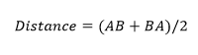

Relative accuracy can be found using the following equation:
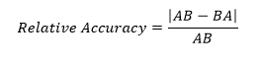

As you measure on sloping ground, remember these important requirements:
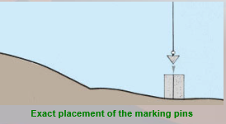
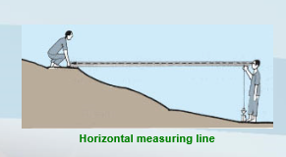

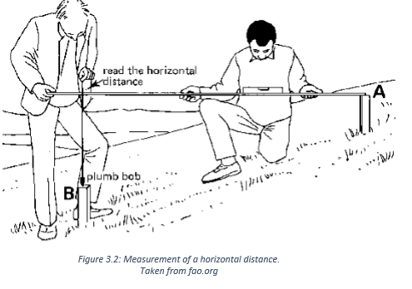

Disadvantages:
- Breaking Tape is sometimes time-consuming.
- It can be less accurate due to the accumulation of errors and not being able to keep the tape aligned.
.

LAB SHEET

Student name: …………………….
ID: …………………………………

1.Find the distance AB uphill and downhill in meters.
2.Find the relative accuracy for the distance AB.
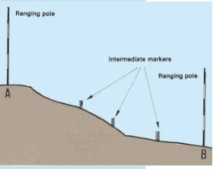

Leveling

Leveling

In this lab, we will practice how to measure elevations using the leveling instrument.

1.Level Instrument
Any leveling job is made up of two components:
1. A telescope to create a line of sight and take readings on graduated rods. 2. A system that enables the orientation of the line of sight horizontally.

2.Leveling Components
a. Telescope
The telescope, shown in Figure 5.1, consists of the following:
1.Objective lens focus: clarifies the view of the object.
2. Eyepiece focus: fixes the focus relate to crosshairs.
3. Leveling screws: used to level the instrument horizontally.
4. Circular level bubble: centering the bubble using the leveling screws ensures a level instrument.
5. Sight or Collimator: allows initial adjustment of telescope’s orientation.
6. Horizontal motion screws: used to slowly move the telescope.

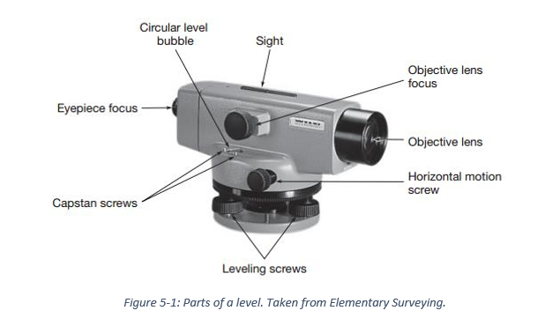
b. Tripod
Tripod legs are made of metal, they can be split, and are adjustable in length. The tripod is shown in Figure 5.2.
c. Level rods
The level rod is graduated in decimeters (1 𝑑𝑚 = 10 𝑐𝑚). When a high rod is needed, it should be extended fully, or else it will result in in a serious reading mistake.
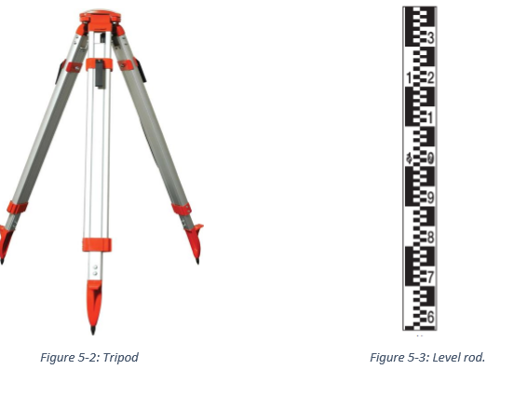

2.Differential Leveling
1.Leveling begins with a benchmark of known location and elevation above sea level.
2. The point for which the elevation needs to be computed is determined.
3. Several intermediate points are determined between the two benchmarks in case the distance is too large.
4. The level instrument is placed between any two points at equal distances. This is done using stadia.
5. A plus sight (Backsight BS) is taken on the initial benchmark, using which the height of instrument (HI) can be determined by:
𝐻𝐼 = 𝑒𝑙𝑒𝑣.𝐴 + 𝐵𝑆
6. After finding the height of instrument, and taking a minus sight (foresight FS) reading on the following intermediate point, the elevation can be easily determined using the following formula:
𝑒𝑙𝑒𝑣.𝐵 = 𝐻𝐼 − 𝐹𝑆
7. The same steps are repeated over all intermediate points, until the desired elevation is determined.
8. Leveling should always be checked by performing elevation loops by returning to the first benchmark. When returning to the initial benchmark, the final elevation should always equal the initial elevation. If not, a loop misclosure exists.
9. It is important to remember that the instrument must be leveled at each point.
10. All values need to be recorded in a table as shown in Table 5.1. Backsight, foresight and height of instrument values are used in order to find elevations.
11. It is important to perform a page check at the end of the calculations; to ensure they are mathematically correct. If the result of the following formula is equal to the last elevation value obtained, then our calculations are correct.
𝑃𝑎𝑔𝑒 𝑐ℎ𝑒𝑐𝑘 = 𝑒𝑙𝑒𝑣.𝐴 + ∑𝐵𝑆 − ∑𝐹𝑆
12. Misclosures are used to determine the leveling accuracy level using:
𝐶 = 𝑚√𝐾
Where: C = misclosure in mm
K = loop perimeter in km
m = constant compared with table 5-1

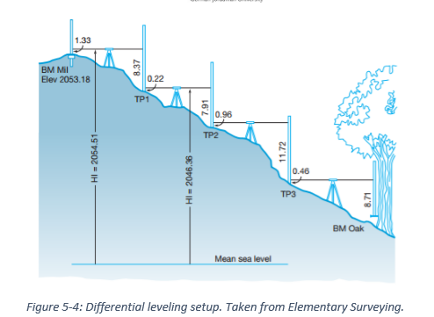

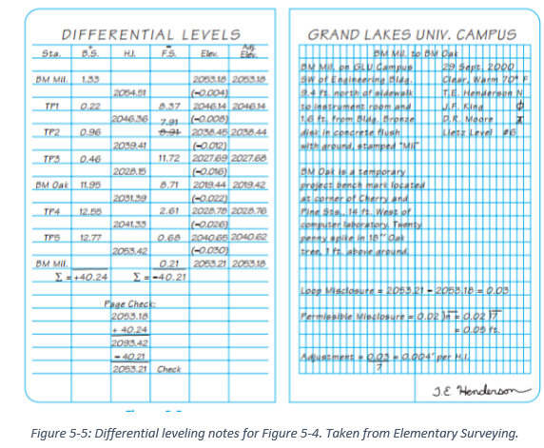

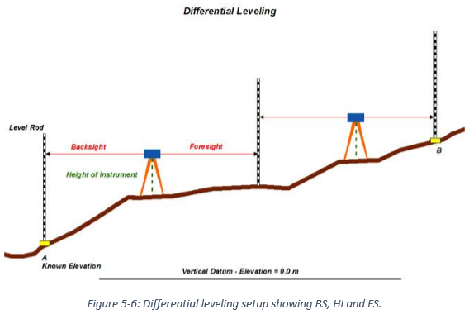

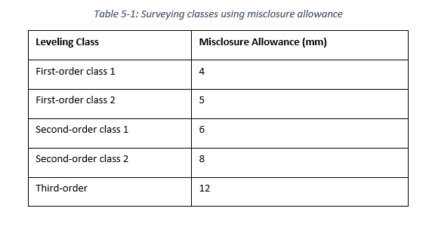

3.Stadia
1. In differential leveling, horizontal distances for the backsight and foresight rods should be made equal.
2. Balancing the distances is done in order to eliminate errors due to instrument maladjustment and the effect of Earth’s curvature.
3. This is done using many methods, including stadia.
4. The stadia method determines the horizontal distance through readings of the upper and lower wires on the reticle.
5. Horizontal distance is equal the difference between upper and lower readings multiplied by a constant. This constant is usually equal to 100. It should be noted that readings are given in dm

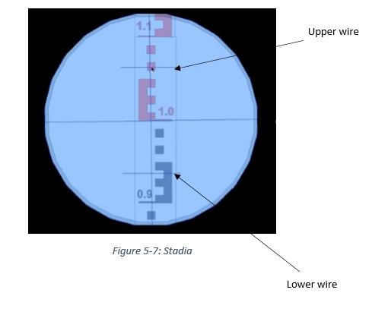

LAB SHEET (exercise no.1)

Student name: …………………….
ID: …………………………………

